Computer Vision and Image Processing

Project Report

*Detecting Circles using Hough Transforms*

By

**Sivakiran Ayyagari**

Masters of Science

Department of Mechanical Engineering

University at Buffalo

# Contents

1. Introduction
2. Approach
3. Outcome and Deviation
4. Explanation of software and program development
5. Summary
6. References

## Introduction

Coin Recognition is a difficult process in Machine Intelligence and computer vision because of it’s never ending shapes, rotations and widely changed input pattern. Coin recognition and detection in messy and overlapping coins is a great challenge. The goal of the project is to detect coins in an image with coins, some even overlapping on others. In this system, a Circular Hough Transform is used to detect the circular shapes from the input image. Circular Hough transform (CHT) is like Hough Transform that can detect circular objects from an image. Hough Transform has two stages, the first one being calculating the accumulator space and the second stage being calculating the peaks of this accumulator space and thereby finding the coordinates and radii of the circles. The Hough Transform was first introduced by Paul Hough in 1962 to detect straight lines in bubble chamber data, the transform which consists of parametric description of a feature at any given location in the original image’s space.

Before CHT, edge detection should be carried out to detect the edges and thresholding should be done to remove the spurious edges and any other unwanted edges. Edge detection can be done using standard edge detection kernels in image processing like x and y Sobel filters or Canny edge detections. After these filters are applied some amount of thresholding and thinning is required to be done. This is because more the edges and unwanted noise would lead to more time in detecting the circles.

## Approach

The approach here was carefully following the guidelines and implementing the algorithm discussed in the course. Some amount of preprocessing was required so as to remove the noise and spurious edges, if not removed would led to more time for completing the task. Two types of edge detections were done namely Sobel and Canny edge detector for getting the edges. The flowchart of this project is given below

Thresholding

Canny Edge detector

Blurring

Preprocessing

Circle Drawing

Center and Radii

Peaks in Array

Accumulator Array

Flow chart 1

The programming language which was used is matlab. Other techniques which were used to detect circles were blurring using Gaussian filter, Edge detection using Sobel Filter, applying Hough Transform, finding radii range, finding the peak in the accumulator array and drawing the circle.

## Outcome and Deviation

For detecting all the circles certain tuning of threshold and range of radius was required. Below are a series of images which attached. They represent various edge detection schemes used.

1. Using Canny edge detector with a threshold of 0.22 and a 3X3 Gaussian filter with sigma of 2.

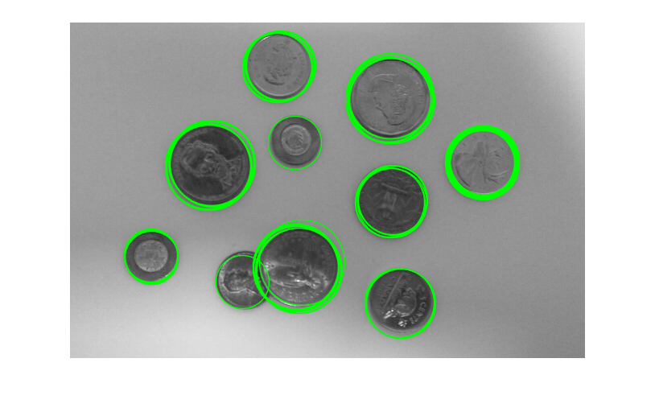

Figure 1: Circle detection using Canny

Edge detector

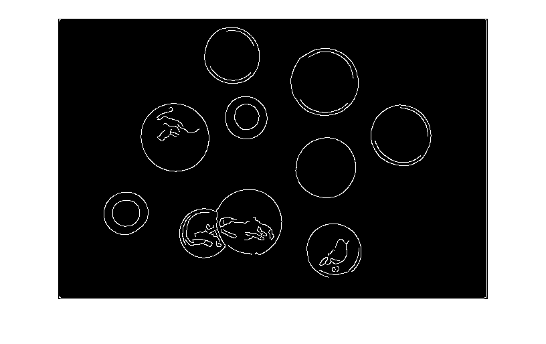

Figure 2: Edge detection using Canny Edge Detector

1. Using Sobel filter threshold of 0.22 and a 3X3 Gaussian filter with sigma of 2.

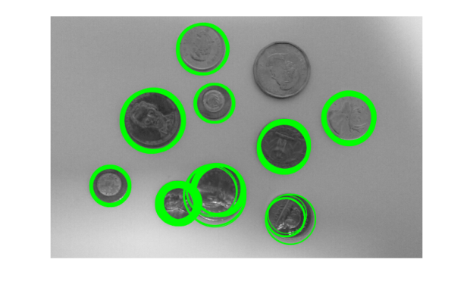

Figure 3: Circle detection using Sobel Filter

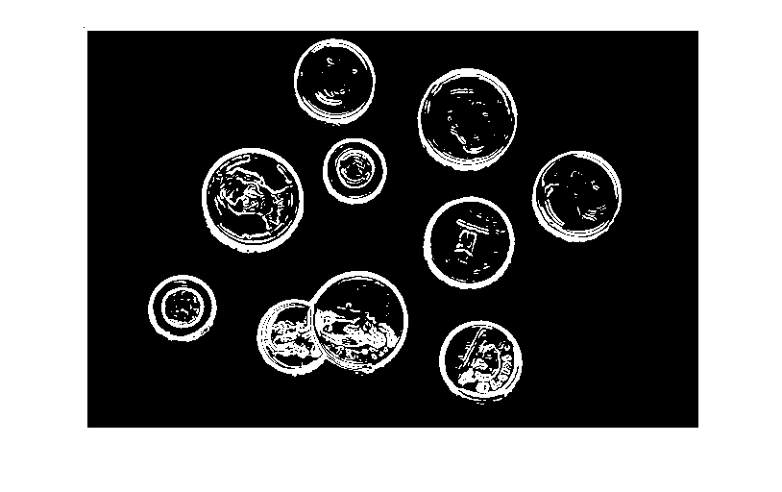

Figure 4: Edge detection using Sobel Filter

From the above figures we got to know that canny edge filter is better as it has detected all the circles compared to Sobel filter. One more thing which was noticed that Sobel filter is that because of the thick edges of the circles, many circles are formed thereby increasing the computation time. One thing which was learned with this algorithm is that the edges should be thinned. It doesn’t matter if there are something inside the circles but if the edges of the circles are thick, multiple circles will be formed and that would lead to high computation time.

## Explanation of Software and Program Development

For this project Matlab was used for software development. It has a very simple and user friendly editor and there is an inbuilt image processing toolbox. This tool box was used for blurring, edge detection using canny edge filter and convolution for sobel filter. The following are the steps followed in order to obtain the detection of circles locating the coins in the image-

* As a part of preprocessing, horizontal and vertical Sobel kernels with values as follows which will be used to perform edge detection on the image by convolution.

-1 -2 -1

1. 0 0
2. 2 1

* Blurring and Gaussian Filter Application: For blurring Gaussian Filter is used which helps in reducing the noise from the image.
* Edge detection using Canny Edge/Sobel filter: Here first canny edge filter will be first discussed

The algorithm is as follows

* + Find the intensity gradients of the image
  + Apply non-maximal suppression to get rid of spurious response to edge detection
  + Apply double threshold to determine the potential edges
  + Track edge by hysteresis
* Detection of Circle

This step is performed to figure out the radius values for the Hough circles to be generated. After hit and trial it was found that the radii with minimum and maximum value required which successfully captures coins of minimum and maximum size.

An accumulator array was created. The algorithm is as follows

* + Initialize accumulator to zero
  + Vote all possible circles in the accumulator
  + The local maximum voted circles of the accumulator gives the circle Hough space
  + The maximum voted circle of accumulator gives the circle
* Displaying the circle on the image. Once radius and circle centers are found, circle is plotted using these parameters.

## Summary

Circles were detected; getting the range of circle radii was an intuitive task. Trial and errors were done for this. It was also found that Canny edge detector gave better edge detection and helped in getting better results compared to sobel filter. In the program a number of test images are used.

## References

[1] Jain, Neelu, and Neha Jain. "Coin recognition using circular Hough transform." *Int. J. Electron. Commun. Comput. Technol* 2.3 (2012)

[2] Roushdy, Mohamed. "Detecting coins with different radii based on hough transform in noisy and deformed image." *the proceedings of GVIP Journal* 7.1 (2007).

[3] Olson, Clark F. "Constrained Hough transforms for curve detection." *Computer Vision and Image Understanding* 73.3 (1999): 329-345.

[4] <https://en.wikipedia.org/wiki/Circle_Hough_Transform>

[5] <https://en.wikipedia.org/wiki/Canny_edge_detector>

[6] <http://homepages.inf.ed.ac.uk/rbf/HIPR2/hough.htm>

[7] Aggarwal, Hanish, and Padam Kumar. "Indian currency note denomination recognition in color images." *International Journal on Advanced Computer Engineering and Communication Technology* 1.1 (2014): 12-18.

[8] <https://www.mathworks.com/help/images/ref/hough.html>